

Project Report

Project Name: DFA

Programming Language: Python

Project Members:

# Description:

1. **Muhammad Bilal F2018266166**

# Obaid Ur Rehman F2018266227

First ,we will make a DFA and the user will give some string that he want to test that whether the given string is accepted by the DFA or not.

# Code Description:

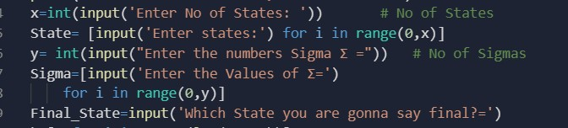

**Fig 1.**

# Fig1 Description:

It will take number of states and the number of Sigma ∑ for the DFA. And it will also take final state as an input. Also ,it is storing the state the in array of state and also it is storing the sigma ∑ in the array of sigma.

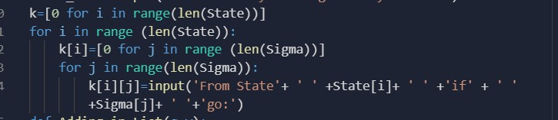

In Fig 2. First of all we are making an array of K which is initializing with zero and it is representing as an array of state. Then , We are making an other array inside the array of State K because we also have to store the moving states of sigma somewhere. And we printing the states of sigma’s ∑ where they are moving.

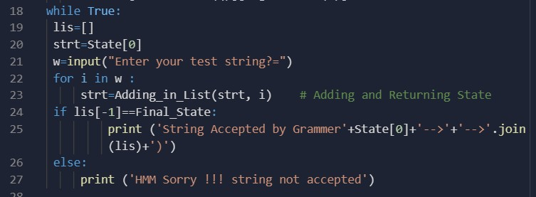

# Fig 3.

This Section will take will take the string and then it will take one letter and will make the starting state Zero . After that when loop will start again starting state will be update and will take another letter and will continue the process until the string will be finished.. It is also comparing that the last index of the string is equal to the final state then the string will be accepted by the DFA that you have made.

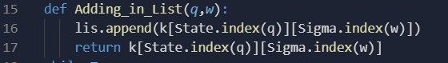

# Fig 4.

This Fig 4 is getting the index of states and sigma’s and adding in to the list and returning it.

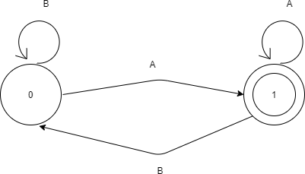

# Fig 5.

——————————————————————————————-

